**Lab Report. 02**

# *Lab Experiment:* Scan Conversion of Circle, Ellipse using (Midpoint algorithm)

*Course Title: Computer Graphics Laboratory*

*Course code: CSE-304*

*3rd Year 1st Semester Examination 2022*

**Date of Submission**: 04/06/2023



###### **Submitted to-**

##### Dr. Mohammad Shorif Uddin

Professor

Dr. Morium Akter

Associate Professor

###### 

###### *Department of Computer Science and Engineering*

*Jahangirnagar University*

*Savar, Dhaka-1342*

|  |  |  |  |
| --- | --- | --- | --- |
| **Sl** | Class Roll | Exam Roll | Name |
| 01 | 347 |  | Sadia Hossain |

**1.Experiment Name: Scan Conversion of Circle using Midpoint algorithm**

**Code:**

**#include <iostream>**

**#include <dos.h>**

**#include <graphics.h>**

**using namespace std;**

**void drawCircle(int xc, int yc, int x, int y)**

**{**

**putpixel(xc+x, yc+y, RED);**

**putpixel(xc-x, yc+y, RED);**

**putpixel(xc+x, yc-y, RED);**

**putpixel(xc-x, yc-y, RED);**

**putpixel(xc+y, yc+x, RED);**

**putpixel(xc-y, yc+x, RED);**

**putpixel(xc+y, yc-x, RED);**

**putpixel(xc-y, yc-x, RED);**

**}**

**void circlemid(int xc, int yc, int r)**

**{**

**int x = 0, y = r;**

**int p=(1-r);**

**drawCircle(xc, yc, x, y);**

**while (y >= x)**

**{**

**x++;**

**if (p> 0)**

**{**

**y--;**

**p+=2*(x-y)+1;**

**}**

**else**

**{**

**p+=2*x+1;**

**}**

**drawCircle(xc, yc, x, y);**

**}**

**}**

**int main()**

**{**

**int xc ,yc,r;**

**int gd = DETECT, gm;**

**cout<<"Enter the center point"<<endl;**

**cin>>xc>>yc;**

**cout<<"Enter the radius"<<endl;**

**cin>>r;**

**initgraph(&gd, &gm,"C:\\TURBOC3\\BGI");**

**circlemid(xc, yc, r);**

**getch();**

**closegraph();**

**return 0;**

**}**

**Output:**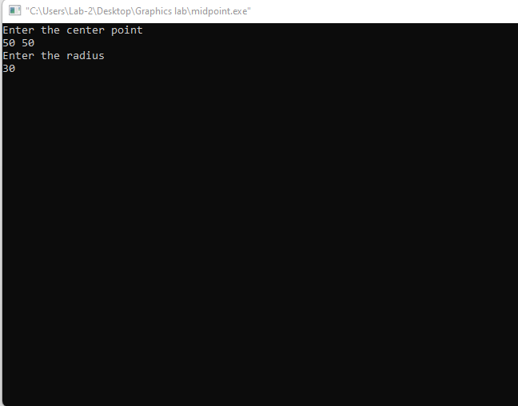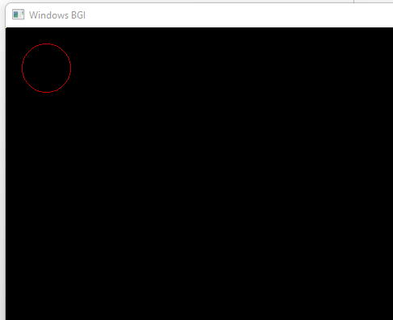

**2.Experiment Name: Scan Conversion of Ellipse using Midpoint algorithm**

**Code:**

**#include<graphics.h>**

**#include<iostream>**

**using namespace std;**

**void elipse(double xc,double yc,double a,double b)**

**{**

**double p=b*b-a*a*b+a*a/4;**

**double x=0, y=b;**

**while(2.0*b*b*x <= 2.0*a*a*y)**

**{**

**x++;**

**if(p < 0)**

**{**

**p = p+2*b*b*x+b*b;**

**}**

**else**

**{**

**y--;**

**p = p+2*b*b*x-2*a*a*y-b*b;**

**}**

**putpixel(xc+x,yc+y,RED);**

**putpixel(xc+x,yc-y,RED);**

**putpixel(xc-x,yc+y,RED);**

**putpixel(xc-x,yc-y,RED);**

**}**

**p=b*b*(x+0.5)*(x+0.5)+a*a*(y-1)*(y-1)-a*a*b*b;**

**while(y > 0)**

**{**

**y--;**

**if(p <= 0)**

**{**

**x++;**

**p = p+2*b*b*x-2*a*a*y+a*a;**

**}**

**else**

**{**

**p = p-2*a*a*y+a*a;**

**}**

**putpixel(xc+x,yc+y,RED);**

**putpixel(xc+x,yc-y,RED);**

**putpixel(xc-x,yc+y,RED);**

**putpixel(xc-x,yc-y,RED);**

**}**

**}**

**int main()**

**{**

**int gd = DETECT, gm;**

**double xc,yc,x,y, a,b;**

**initgraph(&gd, &gm,"C:\\TURBOC3\\BGI");**

**cout<<"Enter coordinates of centre: ";**

**cin>>xc>>yc;**

**cout<<"Enter length of major and minor axix a,b: ";**

**cin>>a>>b;**

**elipse(xc, yc, a, b);**

**getch();**

**closegraph();**

**}**

**Output:**

